

**2022 ANNUAL REPORT**

**CONTENT**

Our Purpose

Year’s Activities

Club Sponsor

New Home

Club History

President’s Report

Secretary & Treasurer’s Report

List of 2022 Members

Financials

**OUR PURPOSE**

1. To encourage, promote, and administer the German Table Tennis Club.
2. To arrange and conduct table tennis training, practice and competitions.
3. To foster the development of the German community in South Australia.

**YOUR 2022 MANAGEMENT COMMITTEE**

**President:** Sef van den Nieuwelaar

**Vice President:** Michael Hemmes

**Secretary/Treasurer:** Tony Stacey

**Member:** Lyndal Ellis

**YEAR’S ACTIVITIES**

### **TABLE TENNIS SOUTH AUSTRALIA (TTSA) Winter Pennant Teams**

### The Club entered a Division 2 Team comprising Paul Grant, Dale McDonald and

### Claire Pickering. The team had a brilliant season and finished as minor premiers with only one loss for the year. Unfortunately the finals did not go to plan, losing the preliminary final.

### Lyndal Ellis competed in the Division 5 Woodville team which qualified for the finals but did not progress.

### During the season, both Warren Wuttke and Hans Vogels supported teams as reserve players.

### **Annual Club Championship - 2022 Club Champion, Michael Lee**

### 

### *Michael defeated Paul Grant in the Final.*

### 

### *2022 Club Championship Participants*

### **Kingston Beach Annual BBQ & Jenny Burford table tennis Competition**

Continuation of the COVID 19 pandemic caused the proposed annual event to be cancelled for the third year in a row.

### Kids in Adelaide | Play | Kingston Park Coastal Reserve

### **Annual Christmas Dinner**

The 2022 German Table Tennis Club Christmas dinner was held on Saturday 19th November 2022 at Bistro 277, former Eagles Footballers Club. The 29 attendees enjoyed the night.

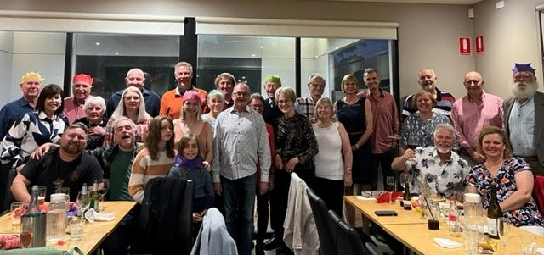

### **Traditional End of Year**

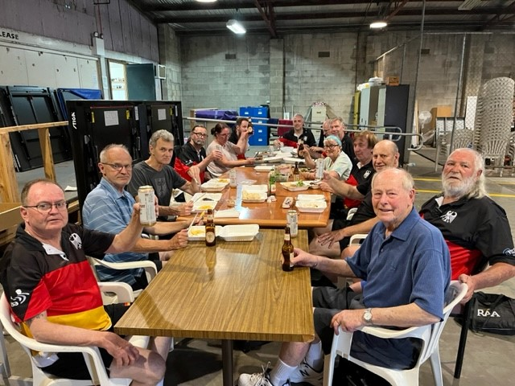At the end of our final practice session for the year, an opportunity to wish members a Merry Christmas and Happy New Year for 2022.

Following the normal practice session, meals were provided by Seven22 and a complimentary beverage was provided.

### **Inter Club Visits**

A challenge with the Adelaide Table Tennis Club was held at Woodville ON Monday 26th October 2022, The night commenced with a great meal arranged and prepared by Michael Hemmes, Manfred Kuhland and their volunteer helpers. The outcome of the five group competition was a draw.

### 

### 

### 

### 

### **Weekly practice sessions on Monday nights**

The availability of six tables was well utilised to play singles and doubles practice matches. Members attended each week in increasing numbers reaching up to 24 on some nights.

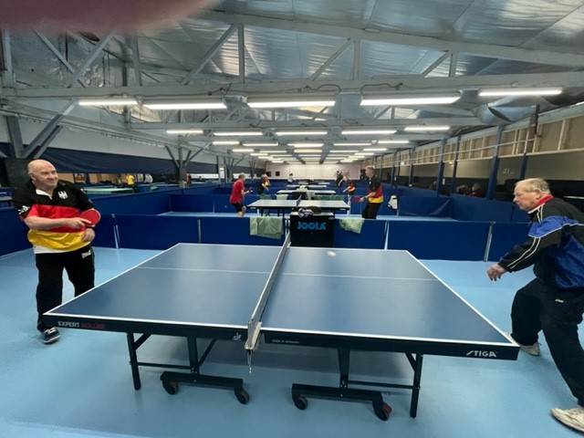

**Continuing Club Sponsor**

Owner of @TSM Consulting, Peter Nicolaci has been supporting grant seeking activities.

Established in 1988, @TSM Consulting works with both private organisations and local communities to assist in the realisation of their visionary projects.

Through consultation with government bodies, peak bodies, private enterprise and local communities, @TSM Consulting assists with project development and identification and achievement of potential funding streams, including grants and other fundraising activities.

**Club Home**

All table tennis for the year was played at the Woodville premises.

The Club was represented on the Woodville Club Board to ensure maintenance of communication and cooperation.

German Table Tennis Club members continued to enjoy social activities after practice. Each Monday night, Sef or Michael organized the ordering and delivery of a broad range of meals from Bistro Seven 22.

**Clubroom Redevelopment**

Work continued implementing the Master Plan which documents the vision of Clubs aims to create an improved facility. It will continue to support German culture, cater for table tennis players and spectator needs. There are numerous health benefits and in particular table tennis is a sport that has no age limit. The three components of the Master Plan are:

**Project 1 – Upgrade Playing Area (Medium Term)**

The table tennis playing floor covering needs to be able to meet Australian standards to ensure maximum use of its 12-table capacity. A specialised playing surface is needed.

At this stage, supply and implementation of the flooring is expected to be completed by April 2023.

Proposed seating for veteran players is also included in this project.

A revised redevelopment plan is currently being documented with completion expected in early 2023.

**Project 2 - Modernise Clubrooms (Highest priority)**

This involves provision of a bistro facility with kitchen facilities, bar and dining meeting rooms. It is to be built by repurposing the northern annex of the existing building. Focus has been on a major clean-up and relocation of storage.

*Image of a similar development that is proposed for Woodville*

**Project 3 – Master Plan Off Street Car Parking Expansion (Long Term Aspiration)**

There is a plan to increase motor vehicle parking off street.

The initial cost estimate of the whole Master Plan implementation was $694,795 plus GST over several years however the critical short-term request for donations is $10,000. You can, through the link below, help by donating through the Australian Sports Foundation and receive a tax deduction today!

[www.asf.org.au/projects/german-table-tennis-club/](http://www.asf.org.au/projects/german-table-tennis-club/)

**Club History**

The table tennis group has been part of the South Australian German Association (SAADV) since 1958. Its loyal members have varied annually from a previously capped number of 20 to this year’s 31. Numbers are 20% higher than last year’s, because of the COVID pandemic subsidence and word of mouth promotion by several Club members. They have ranged from teenagers through to veterans and from beginners through to members with some past players ranked in Australia’s top 100.

Club practice for many years was in the Friedrich Jahn Gymnasium on four tables, generally followed by a few drinks in the downstairs bar. Practice is now at Woodville on six permanently erected tables. Our Club is affiliated with Table Tennis SA and several our members compete in the winter pennant competitions, both for our Club and other table tennis clubs.

Our Club has each year organised many social activities BBQs, Annual beach BBQ, exchanges with other table tennis clubs (Brighton & Adelaide) and our Christmas Dinners being the social highlight of the year. All table tennis enthusiasts, whether beginner or advanced are invited to come and have trial games. 2022 was able to achieve membership enticement of several former great table tennis players.

*Stammtisch Table Sign*

**President’s Report**

It’s with pleasure I present this year’s German Table Tennis Club President report.

Despite the world still being dominated by the Covid pandemic, 2022 turned out to be a really good year for our club. I recall in the beginning of the year there was still a reluctance to gather indoors for sporting events and we’d get almost weekly updates from the authorities on what we could and couldn’t do. We also had to make the difficult decision to make vaccination mandatory in Iine with other sporting organisations.

We even had to cancel our annual BBQ and Jenny Burford trophy tournament for the third year in a row.

However gradually things improved, mask mandates were dropped and life returned to some form of normality. We also welcomed back our members and very pleasingly gained quite a few new members in Anthony Debono, Michael Debono, Con Gatis, Michael Lee, Adrian Macolino, Hans Vogels, Steven Wagstaff and Warren Wuttke. Welcome to you all!

Activity wise in the second half of the year we often had in excess of 20 members and guests play on our Monday club nights. Seven 22 Bistro has been a great supporter for us and most Monday nights we have been able to offer their $15 dinner special to our members after training. And with WDTTC newly acquired liquor license we were also able to offer $5 beers and ciders. As a result things often would get quite animated around our Stammtisch at the end of the practice night!

As you can read in the report our extra events this year were very well frequented and equally well received and I am looking forward to continuing these events as we enter our new club year. Hopefully 2023 will bring us a new playing surface, further improvements to our canteen area, further membership growth and most of all a continuation of the comradery that makes our club so unique!

**Secretary & Treasurer’s Report**

This report covers the period from 1 January to 31 December 2022.

The COVID 19 pandemic restrictions only curtailed normal Club social activities in early 2022.

The Club finances are a very healthy $11,747 cash in the bank as at 31 December 2022. Conservative use of Club money is still being maintained as the Club prepares to support the Woodville District Table Tennis Club for redevelopment of its premises at Woodville. In preparation for the proposed Clubroom upgrade, the Club has an operating account ($7,196) and Building Fund Account ($4,551), the latter including donations from the Australian Sports Foundation and individual donors.

The Club has 4 years left in a 5 year tenancy agreement which is expected to be renewed at the end of that period. Work has worked with the Woodville Club to jointly design and implement redevelopment of the Clubrooms, a project to provide a modern, clean social area for all members and to update current playing standard facilities.

Club fees were increased from $50 to $55 per member, the first change since 2015. An additional fee of $20 per member was imposed by TTSA to ensure that all recreational table tennis players had an accident insurance cover. A user pay fee of $5 per session was maintained to nightly practice.

The introduction in 2022 of the Square Point of Sale system replaced the need to handle cash. Also debit cards issued to the President, Vice President and Secretary streamlined the purchase of Club Member meals and drinks.

The Club has continued to maintain a friendly atmosphere with all members contribution in their own way to support ongoing Club operations.

Groundwork has been time consuming during 2021 and 2022 working with Charles Sturt Council to finalise and support the planned redevelopment.

**2022 Members**

Bemmerl, Werner

Bigalske, Gus (Life)

Bilogrevic, Strav

Bonner, Lloyd

Debono, Anthony

Debono, Michael

Ellis, Lyndal

Lamb, Robert (Life)

Gatis, Constantine

Grant, Paul

Hemmes, Michael

Henn, Ulrich

Jaremyn, Daniela

Kosiol, Dieter

Langhans, Geoff

Lee, Michael

Lowe, David

McDonald, Dale

Macolino, Adrian

Mentzel, Patrick

Nieuwelaar, van den Sef

Nikelis, Martin

Pickering, Claire

Pottel, Rainer

Smith, Robert

Solly, Kevin

Stacey, Tony

Taylor, Grayham

Vogels, Hans

Wagstaffe, Steven

Wuttke, Warren

**Financial Statement**

**31/12/2022 German Table Tennis Club Incorporated**

|  |  |  |  |  |  |  |  |
| --- | --- | --- | --- | --- | --- | --- | --- |
|  | | **2022** | | **2021** | | **2020** | |
|  | | **$** | | **$** | |
| **Income** | |  | |  | |  | |
| Grants | | - | | 2,360 | | 1,000 | |
| Membership Fees | | 1,980 | | 1,130 | | 1,375 | |
| Member contributions to social functions | | - | | - | | - | |
| Membership TT Insurance | | - | | 340 | | - | |
| BBQ/Dinner Drinks | | 5,739 | | 1,978 | | 198 | |
| Player registration contribution | | - | | 280 | | 75 | |
| Uniform Sales | | 150 | | 90 | | - | |
| Woodville Venue Hire – Players | | 2,640 | | 2,114 | | 1,659 | |
| **Total Income** | | **10,509** | | **8,292** | | **4,307** | |
| **Expenditure** | |  | |  | |  | |
| Annual Picnic expenses | | - | | - | | - | |
| BBQ & Dinner Drinks | | 4,242 | | 1,200 | | 153 | |
| Christmas Function plus Dinner Expenses | | 360 | | 291 | | 103 | |
| Constitution update | | 76 | | - | | - | |
| Equipment (TT Barriers, Nets & Balls) | | 16 | | - | | 141 | |
| Equipment (Square POS & Cabinet) | | 246 | | 471 | | - | |
| Player Registration | | 575 | | 440 | | - | |
| Stationery | | - | | 5 | | 25 | |
| Table Tennis SA Affiliation Fee | | 300 | | 30 | | 270 | |
| Table Tennis Club Visit Expenses | | 383 | | 91 | | - | |
| Table Tennis Winter Fees | | - | | 200 | | - | |
| Trophy Engraving | | 11 | | 66 | | - | |
| Uniform Purchases | | 338 | | - | | 1,029 | |
| Website | | - | | 2,360 | | - | |
| Woodville Venue Hire | | 1,760 | | 1,404 | | 1,105 | |
| **Total Expenditure** | | **8,307** | | **6,558** | | **2,826** | |
| **Annual Surplus/(Deficit)** | | **2,202** | | **1,734** | | **1,482** | |
| **CASH AT BANK** | | **Operating** | | **Building Fund** | | **TOTAL** | |
| Bank Statement 1 January 2022 | | 4,994 | | 4,529 | |  | |
| Income 1/01/2022 – 31/12/2022 | | 10,509 | | - | |  | |
| Australian Sports Foundation | | - | | - | |  | |
| Donation | | - | | - | |  | |
| Interest | | - | | 22 | |  | |
|  | | 15,503 | | 4,551 | |  | |
| Expenditure 1/01/2022 – 31/12/2022 | | 8,307 | | - | |  | |
| **BANK Statement as at 31 December 2022** | | **7,196** | | **4,551** | | **11,747** | |